UNITED STATES

SECURITIES AND EXCHANGE COMMISSION

Washington, D. C. 20549

FORM 8-K

CURRENT REPORT

Pursuant to Section 13 or 15(d)

of the Securities Exchange Act of 1934

Date of Report (Date of earliest event reported): August 14, 2018

DIAMONDBACK ENERGY, INC.

(Exact name of registrant as specified in its charter)

Delaware | 001-35700 | 45-4502447
(State or other jurisdiction | (Commission | (I.R.S. Employer
of incorporation) | File Number) | Identification No.)
500 West Texas
Suite 1200
Midland, Texas |  | 79701
(Address of principal executive offices) |  | (Zip Code)

(432) 221-7400

(Registrant’s telephone number, including area code)

Not Applicable

(Former name or former address, if changed since last report)

Check the appropriate box below if the Form 8-K filing is intended to simultaneously satisfy the filing obligation of the registrant under any of the following provisions:

- Written communications pursuant to Rule 425 under the Securities Act (17 CFR 230.425)

- Soliciting material pursuant to Rule 14a-12 under the Exchange Act (17 CFR 240.14a-12)

- Pre-commencement communications pursuant to Rule 14d-2(b) under the Exchange Act (17 CFR 240.14d-2(b))

- Pre-commencement communications pursuant to Rule 13e-4(c) under the Exchange Act (17 CFR 240.13e-4(c))

Indicate by check mark whether the registrant is an emerging growth company as defined in Rule 405 of the Securities Act of 1933 (§230.405 of this chapter) or Rule 12b-2 of the Securities Exchange Act of 1934 (§240.12b-2 of this chapter).

Emerging growth company ☐

If an emerging growth company, indicate by check mark if the registrant has elected not to use the extended transition period for complying with any new or revised financial accounting standards provided pursuant to Section 13(a) of the Exchange Act. ☐

Item 7.01. Regulation FD Disclosure.

Diamondback Energy, Inc. (“Diamondback”) posted an updated investor presentation relating to the proposed merger discussed in Item 8.01 below to Diamondback’s website. The updated presentation can be found at www.diamondbackenergy.com under the “Events & Presentations” section on the “Investors” page. Information on Diamondback’s website does not constitute a part of this Current Report on Form 8-K. A copy of the investor presentation is attached hereto as Exhibit 99.1.

Item 8.01. Other Events.

On August 14, 2018, Diamondback and Energen Corporation (“Energen”) issued a joint press release announcing their entry into an agreement and plan of merger, by and among Diamondback, Energen and Sidewinder Merger Sub Inc., a wholly owned subsidiary of Diamondback. A copy of the press release is attached as Exhibit 99.2 to this report and incorporated herein by reference.

Item 9.01. Financial Statements and Exhibits.

- Exhibits.

Exhibit No. |  | Description of Exhibit
99.1 |  | Investor presentation, dated August 14, 2018, entitled “Transformational Combination with Energen.”
99.2 |  | Joint press release, dated as of August 14, 2018.

Additional Information and Where to Find it

This report does not constitute an offer to buy or sell or the solicitation of an offer to buy or sell any securities or a solicitation of any vote or approval. This communication relates to a proposed business combination between Diamondback and Energen. In connection with the proposed transaction, Diamondback intends to file with the Securities and Exchange Commission (the “SEC”) a registration statement on Form S-4 that will include a joint proxy statement of Diamondback and Energen that also constitutes a prospectus of Diamondback. Each of Diamondback and Energen also plan to file other relevant documents with the SEC regarding the proposed transaction. No offering of securities shall be made except by means of a prospectus meeting the requirements of Section 10 of the U.S. Securities Act of 1933, as amended. Any definitive joint proxy statement/prospectus of Diamondback and/or Energen (if and when available) will be mailed to shareholders of Diamondback and/or Energen, as applicable. INVESTORS AND SECURITY HOLDERS OF DIAMONDBACK AND ENERGEN ARE URGED TO READ THE REGISTRATION STATEMENT, JOINT PROXY STATEMENT/PROSPECTUS AND OTHER DOCUMENTS THAT MAY BE FILED WITH THE SEC CAREFULLY AND IN THEIR ENTIRETY IF AND WHEN THEY BECOME AVAILABLE BECAUSE THEY WILL CONTAIN IMPORTANT INFORMATION ABOUT THE PROPOSED TRANSACTION. Investors and security holders will be able to obtain free copies of these documents (if and when available) and other documents containing important information about Diamondback and Energen, once such documents are filed with the SEC through the website maintained by the SEC at http://www.sec.gov. Copies of the documents filed with the SEC by Diamondback will be available free of charge on Diamondback’s website at http://www.diamondbackenergy.com or by contacting Diamondback’s Investor Relations Department by email at IR@Diamondbackenergy.com, alawlis@diamondbackenergy.com, or by phone at 432-221-7467. Copies of the documents filed with the SEC by Energen will be available free of charge on Energen website at http://www.energen.com or by phone at 205-326-2634.

Certain Information Concerning Participants

Diamondback, Energen and certain of their respective directors and executive officers may be deemed to be participants in the solicitation of proxies in respect of the proposed transaction. Information about the directors and executive officers of Energen is set forth in Energen’s proxy statement for its 2018 annual meeting of shareholders, which was filed with the SEC on March 22, 2018. Information about the directors and executive officers of Diamondback is set forth in its proxy statement for its 2018 annual meeting of shareholders, which was filed with the SEC on April 27, 2018. These documents can be obtained free of charge from the sources indicated above. Other information regarding the participants in the proxy solicitations and a description of their direct and indirect interests, by security holdings or otherwise, will be contained in the joint proxy statement/prospectus and other relevant materials to be filed with the SEC when such materials become available. Investors should read the joint proxy statement/prospectus carefully when it becomes available before making any voting or investment decisions. You may obtain free copies of these documents from Diamondback or Energen using the sources indicated above.

Cautionary Statement Regarding Forward-Looking Information

This report contains forward-looking statements within the meaning of the Private Securities Litigation Reform Act of 1995. All statements, other than historical facts, that address activities that Diamondback or Energen assumes, plans, expects, believes, intends or anticipates (and other similar expressions) will, should or may occur in the future are forward-looking statements. The forward-looking statements are based on management’s current beliefs, based on currently available information, as to the outcome and timing of future events, including this proposed transaction and the previously announced Ajax transaction. These forward-looking statements involve certain risks and uncertainties that could cause the results to differ materially from those expected by the management of Diamondback or Energen. These include the expected timing and likelihood of completion of the proposed transaction, including the timing, receipt and terms and conditions of any required governmental and regulatory approvals of the proposed transaction that could reduce anticipated benefits or cause the parties to abandon the proposed transaction, the ability to successfully integrate the businesses, the occurrence of any event, change or other circumstances that could give rise to the termination of the merger agreement, the possibility that stockholders of Diamondback may not approve the issuance of new shares of common stock in the proposed transaction or that shareholders of Energen may not approve the merger agreement, the risk that the parties may not be able to satisfy the conditions to the proposed transaction in a timely manner or at all, risks related to disruption of management time from ongoing business operations due to the proposed transaction, the risk that any announcements relating to the proposed transaction could have adverse effects on the market price of Diamondback’s common stock or Energen’s common stock, the risk of any unexpected costs or expenses resulting from the proposed transaction, the risk of any litigation relating to the proposed transaction, the risk that the proposed transaction and its announcement could have an adverse effect on the ability of Diamondback and Energen to retain customers and retain and hire key personnel and maintain relationships with their suppliers and customers and on their operating results and businesses generally, the risk the pending proposed transaction could distract management of both entities and they will incur substantial costs, the risk that problems may arise in successfully integrating the businesses of the companies, which may result in the combined company not operating as effectively and efficiently as expected, the risk that the

combined company may be unable to achieve synergies or other anticipated benefits of the proposed transaction or it may take longer than expected to achieve those synergies or benefits and other important factors that could cause actual results to differ materially from those projected. All such factors are difficult to predict and are beyond Diamondback’s or Energen’s control, including those detailed in Diamondback’s annual reports on Form 10-K, quarterly reports on Form 10-Q and current reports on Form 8-K that are available on its website at http://www.diamondbackenergy.com and on the SEC’s website at http://www.sec.gov, and those detailed in Energen’s annual reports on Form 10-K, quarterly reports on Form 10-Q and current reports on Form 8-K that are available on Energen’s website at http://www.energen.com and on the SEC’s website at http://www.sec.gov.

All forward-looking statements are based on assumptions that Diamondback or Energen believe to be reasonable but that may not prove to be accurate. Any forward-looking statement speaks only as of the date on which such statement is made, and Diamondback and Energen undertake no obligation to correct or update any forward-looking statement, whether as a result of new information, future events or otherwise, except as required by applicable law. Readers are cautioned not to place undue reliance on these forward-looking statements that speak only as of the date hereof.

SIGNATURE

Pursuant to the requirements of the Securities Exchange Act of 1934, the registrant has duly caused this report to be signed on its behalf by the undersigned hereunto duly authorized.

DIAMONDBACK ENERGY, INC.
Date: August 14, 2018
By: | /s/ Teresa L. Dick
Name: | Teresa L. Dick
Title: | Chief Financial Officer, Executive Vice President and Assistant
 | Secretary

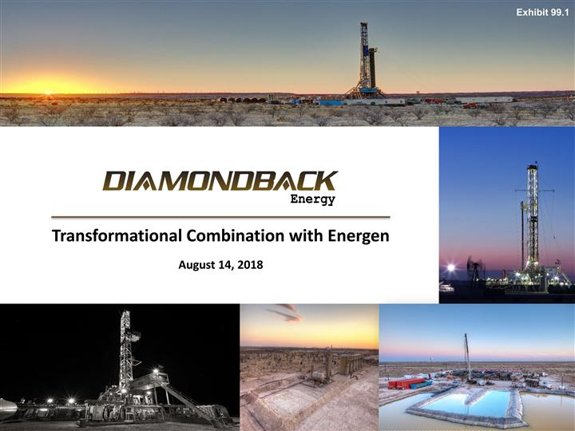

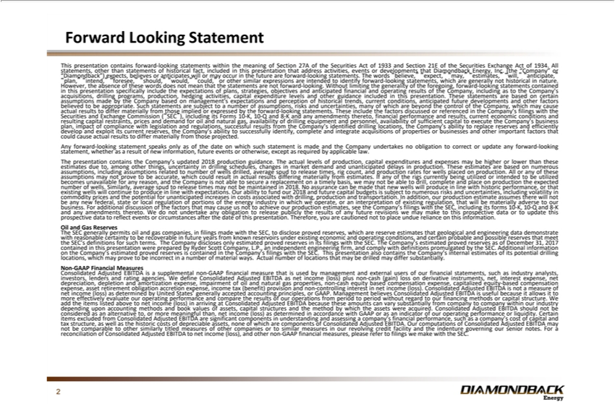

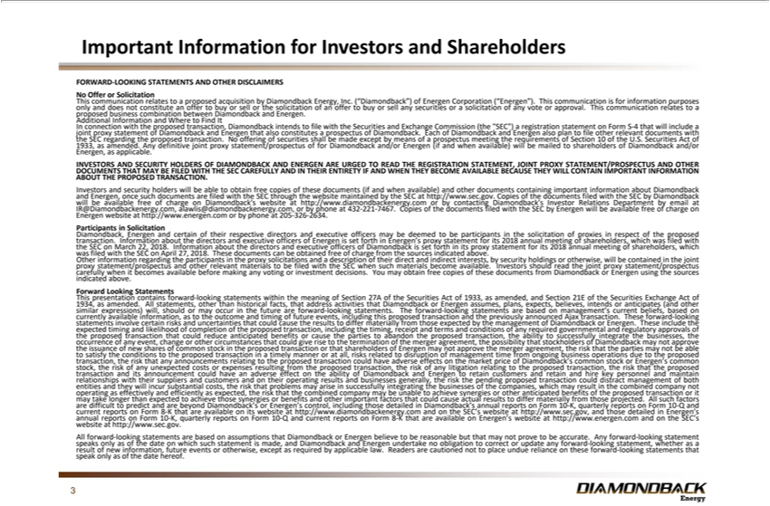

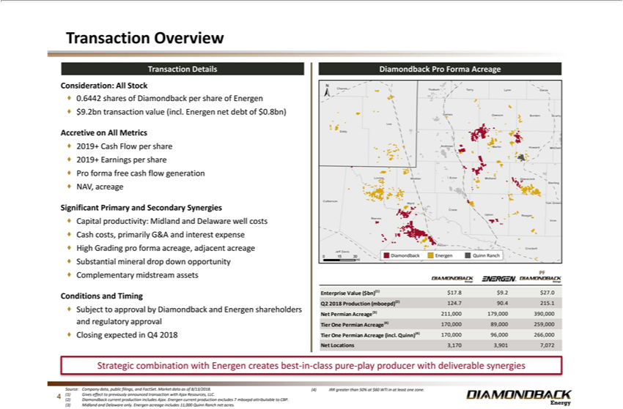

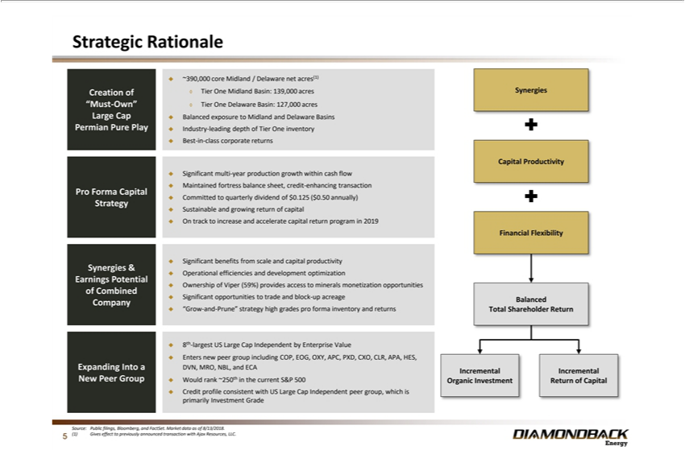

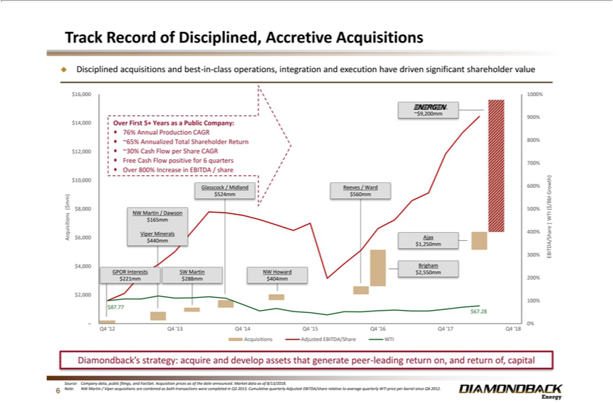

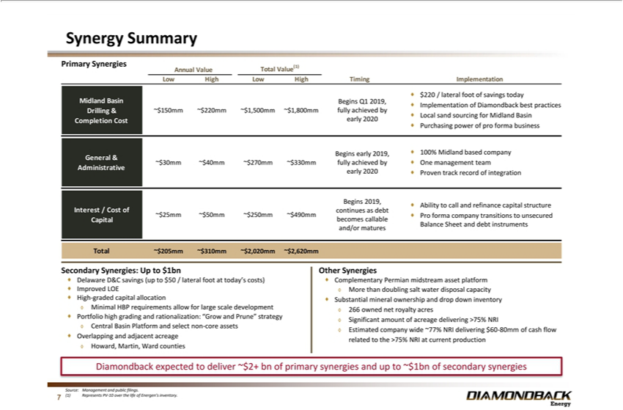

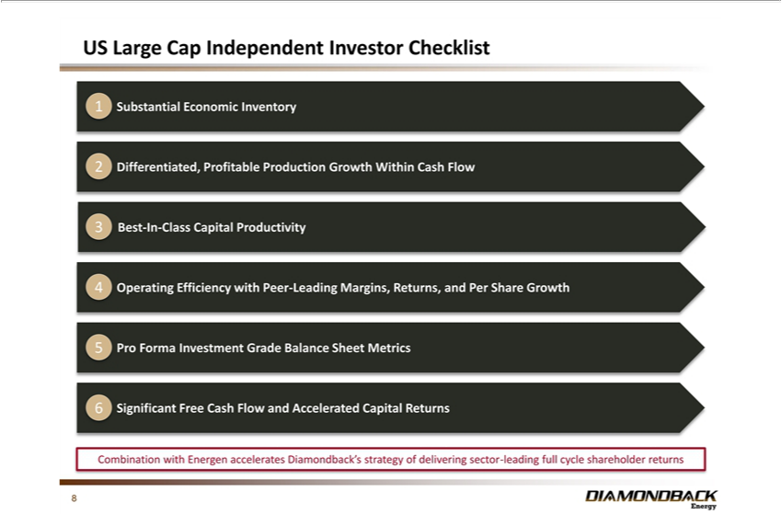

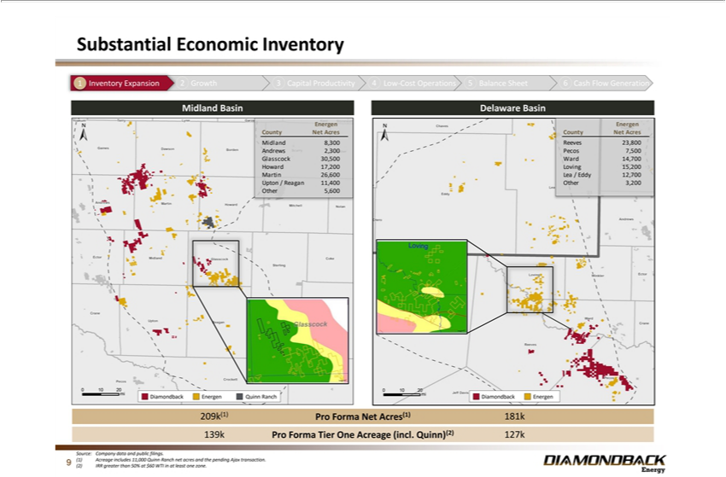

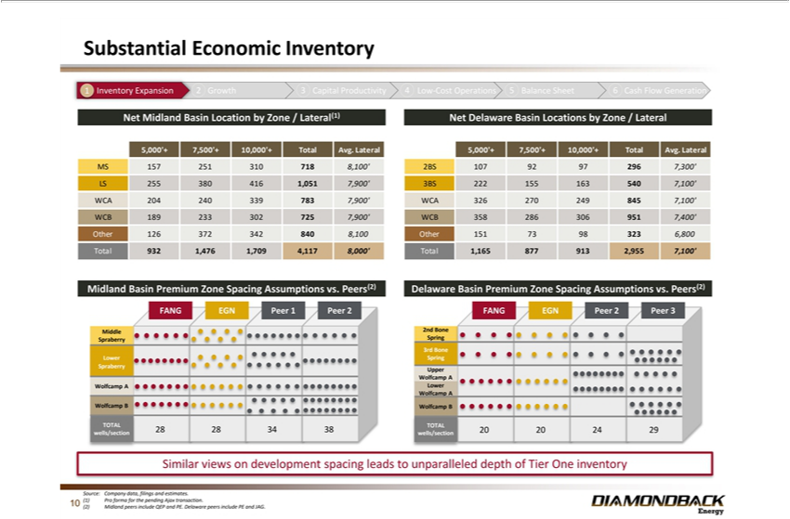

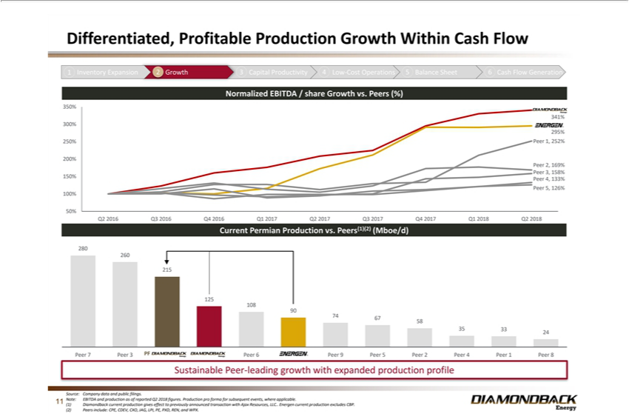

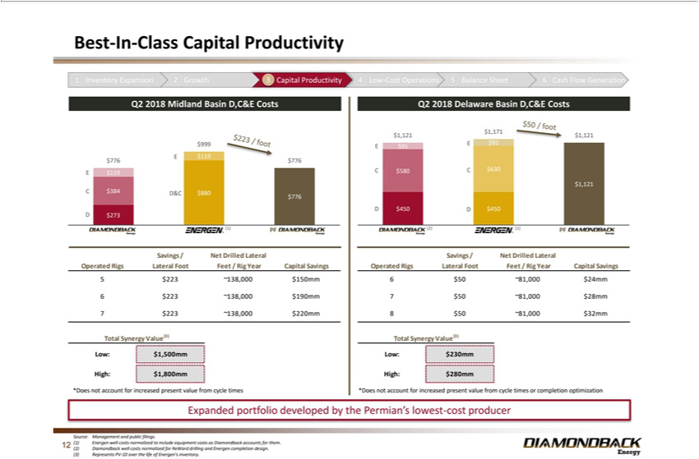

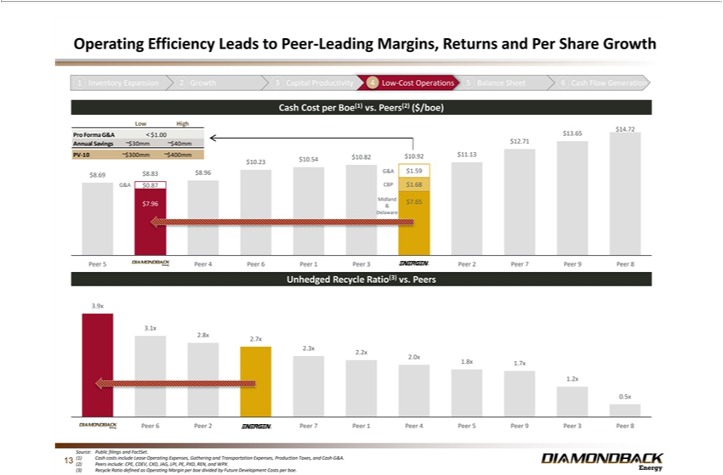

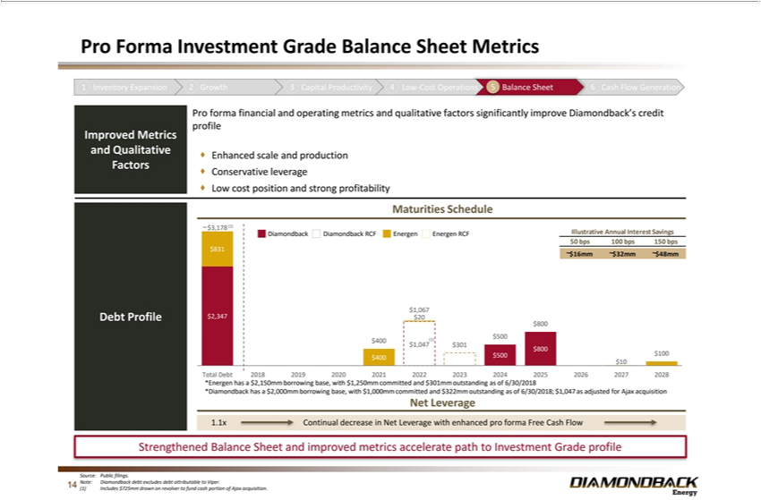

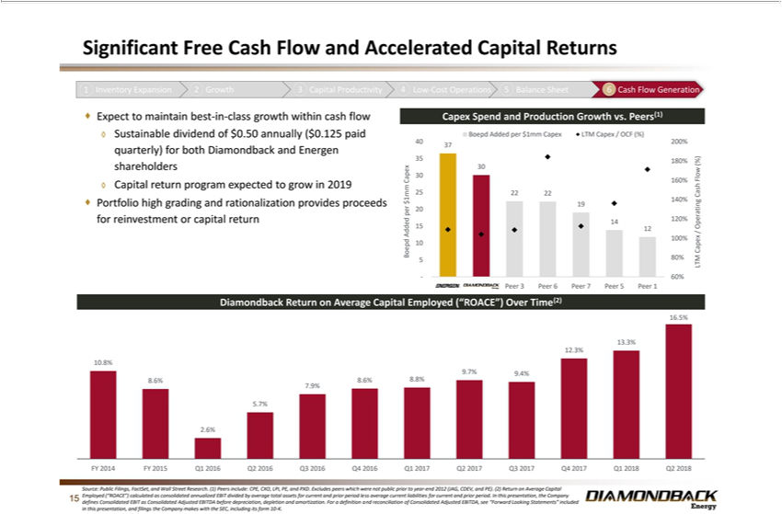

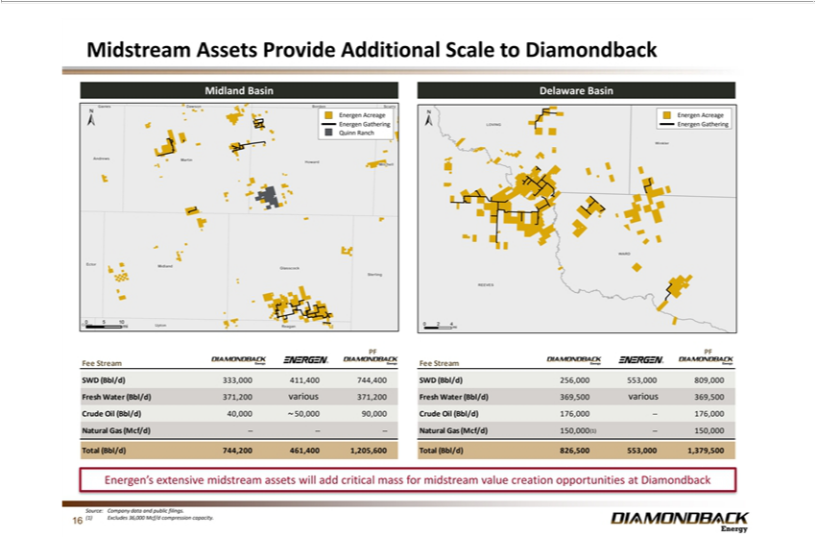

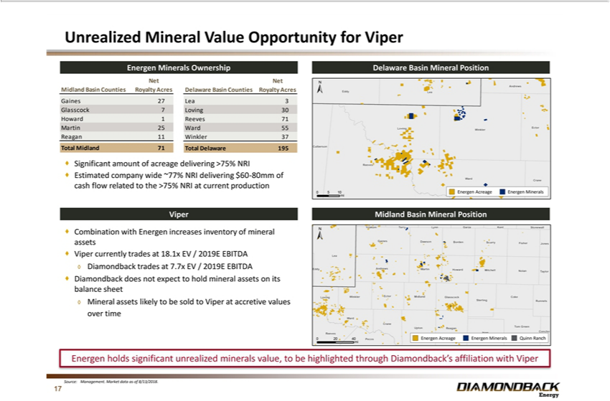

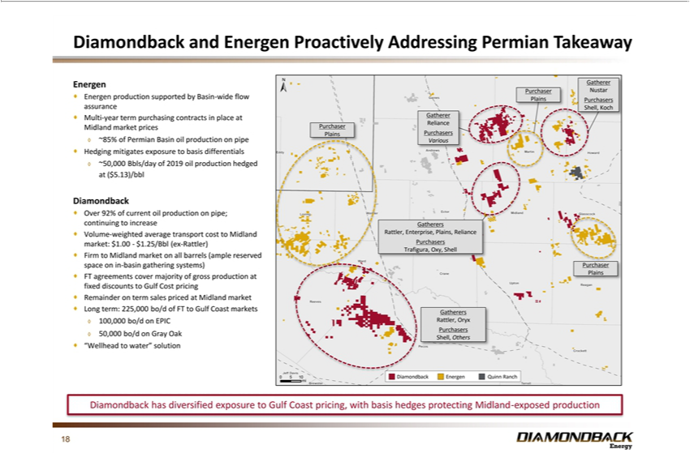

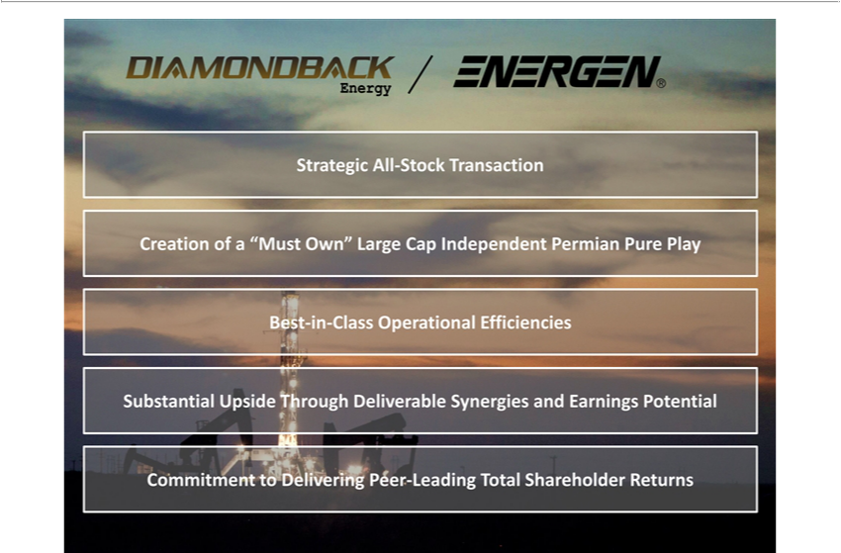

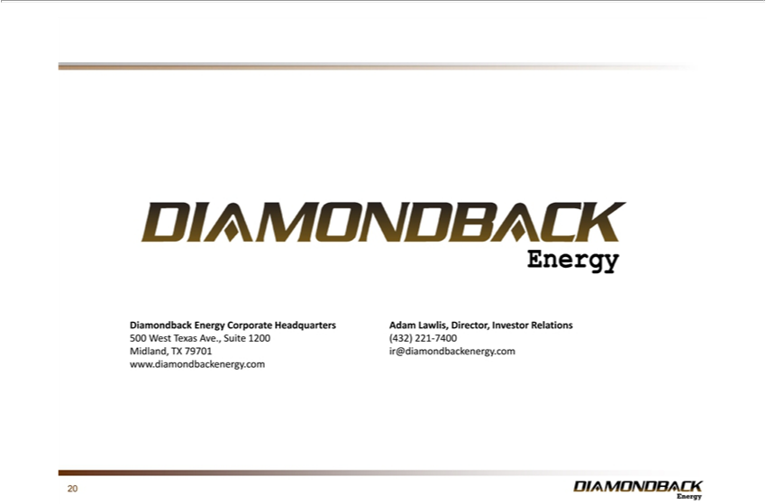

Exhibit 99.2
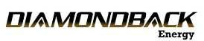

DIAMONDBACK ENERGY, INC. TO ACQUIRE ENERGEN CORPORATION IN ALL-STOCK TRANSACTION

Midland, TX (August 14, 2018) – Diamondback Energy, Inc. (NASDAQ: FANG) (“Diamondback” or the “Company”) and Energen Corporation (NYSE: EGN) or (“Energen”), today announced that they have entered into a definitive agreement under which Diamondback will acquire Energen in an all-stock transaction valued at approximately $9.2 billion, including Energen’s net debt of $830 million as of June 30, 2018. The consideration will consist of 0.6442 shares of Diamondback common stock for each share of Energen common stock, representing an implied value to each Energen shareholder of $84.95 per share based on the closing price of Diamondback common stock on August 13, 2018. The transaction was unanimously approved by the Board of Directors of each company.

TRANSACTION HIGHLIGHTS:

- Creates the premier large cap Permian independent with peer-leading production growth, cost structure and capital efficiency

- Over 266,000 net Tier One acres in the Permian Basin, an increase of 57% from Diamondback’s current Tier One acreage of approximately 170,000 net acres (pro forma for previously announced Ajax acquisition)
- Over 7,000 estimated total net horizontal Permian locations, an increase of over 120% from Diamondback’s current estimated net locations (pro forma for previously announced Ajax acquisition)
- Combined pro forma Q2 2018 production of over 222 Mboe/d (67% oil), third largest production for a pure play company in the Permian Basin, an increase of 79% from Diamondback’s Q2 2018 production of 124.7 Mboe/d (includes production from the previously announced Ajax acquisition)

- 390,000 net acres across the Midland and Delaware basins, an increase of 85% from 211,000 net acres as of June 30, 2018 (pro forma for previously announced Ajax acquisition)
- Immediately accretive in 2019 on key per-share metrics including: earnings per share, cash flow per share, net asset value, production growth per debt-adjusted share and acreage
- Free cash flow enhancement expected to support increases in return of capital; Diamondback dividend to be maintained and growth in return of capital program to be assessed in 2019
- Held by production nature of assets allows for development optimization with multi-zone, multi-well pads in both Midland and Delaware Basins

- Primary deliverable synergies with net present value of $2.0 billion or more include:

oCapital Productivity: Drilling, completion and equip (“D,C&E”) well cost savings of up to $200 per lateral foot across over 2,000 net operated locations in the Midland Basin
o Estimated annual general and administrative (“G&A”) savings of $30 – $40 million o Lower cost of capital and accelerated path to investment grade profile
oPrimary deliverable synergies expected to be realized beginning in 2019

- Secondary synergies with net present value of $1.0 billion or more include:

o Capital Productivity: D,C&E well cost savings of up to $50 per lateral foot across over 1,500 net operated locations in the Delaware Basin o Benefits of economies of scale
oBenefit of overlapping and adjacent acreage in Howard, Martin and Ward counties

- Lease operating expense reduction

- High grading of inventory allows for cash flow acceleration and reinvestment

- “Grow and prune” strategy for non-core assets with cash reinvested into higher return projects

- Substantial mineral ownership and acreage with net revenue interest greater than 75%, providing compelling drop down opportunities for Viper Energy Partners LP
- Combination of significant midstream assets across both Midland and Delaware basins

- Secondary synergies expected to be realized post integration

“This transaction represents a transformational moment for both Diamondback and Energen shareholders as they are set to benefit from owning the premier large cap Permian independent with industry leading production growth, operating efficiency, margins and capital productivity supporting an increasing capital return program. The Energen team has done an outstanding job assembling a portfolio of Tier One acreage in both the Midland and Delaware basins, which, when combined with Diamondback’s current portfolio, will present an extended runway for Diamondback’s record of best-in-class execution and low-cost operations. This transaction also adds critical mass for driving capital efficiencies in what is now truly becoming a manufacturing business. I expect the pro forma company to be able to grow at industry leading rates while returning capital at a competitive yield,” stated Travis Stice, Chief Executive Officer of Diamondback.

Mr. Stice continued, “We look forward to welcoming Energen’s employees as members of the Diamondback team, and applaud them for the hard work and dedication they have put forth to create this opportunity for the two teams to become one. The synergies provided in this transaction, as well as the opportunities for capital improvements provided by increased size and scale, create a truly outstanding value proposition. The combined company’s expected production growth, capital productivity and cost structure will enhance our free cash flow profile to grow our long-term capital return program.”

James McManus, Chairman and Chief Executive Officer of Energen, stated, “We are very pleased about this transaction and believe the combination of the two companies’ quality assets, track record of execution, and peer-leading cost structures will form an even stronger, large-cap independent producer uniquely positioned to drive growth and development in the Permian Basin. This transaction is the outcome of a comprehensive strategic review by Energen’s Board with the assistance of our outside advisors. The process examined our business plan, competitive positioning, and strategic alternatives. We believe this all-stock transaction with Diamondback is the best path forward for our company and provides Energen shareholders with an excellent value for their investment, now and in the future.”

Mr. McManus added, “I also want to take this opportunity to recognize Energen’s biggest strength, our employees, and publicly thank them for their dedication and hard work in driving Energen’s success.”

TRANSACTION DETAILS

Under the terms of the definitive merger agreement, shareholders of Energen will receive 0.6442 shares of Diamondback common stock in exchange for each share of Energen common stock, representing an implied value to each Energen shareholder of $84.95 per share based on the closing price of Diamondback common stock on August 13, 2018. The consideration represents an approximately 19% premium to Energen’s closing price of $71.36 on August 13, 2018. Upon closing the transaction, Diamondback shareholders will own approximately 62% of the combined company, and Energen shareholders will own approximately 38%.

The resulting capital structure is consistent with Diamondback’s strategy of maintaining a conservative financial profile and will accelerate the Company’s path to an investment grade credit rating profile.

The transaction, which is expected to be completed by the end of the fourth quarter of 2018, is subject to the approval of both Diamondback and Energen shareholders, the satisfaction of certain regulatory approvals and other customary closing conditions.

Upon closing, Diamondback’s Board of Directors and executive team will remain unchanged. Additionally, the Company will continue to be headquartered in Midland, Texas.

ADVISORS

Citigroup Global Markets, Inc. is acting as exclusive financial advisor to Diamondback, and Akin Gump Strauss Hauer & Feld LLP is acting as legal advisor to Diamondback. J.P. Morgan Securities LLC and Tudor, Pickering, Holt & Co are acting as exclusive financial advisors to Energen, and Wachtell, Lipton, Rosen & Katz is acting as legal advisor to Energen.

CONFERENCE CALL

Diamondback will host a conference call and webcast for investors and analysts to discuss the proposed transaction on Wednesday, August 15, 2018 at 7:30 a.m. CT. Participants should call (877) 440-7573 (United States/Canada) or (253) 237-1144 (International) and use the confirmation code 1539287. A telephonic replay will be available from 10:30 a.m. CT on Wednesday, August 15, 2018 through Wednesday, August 22, 2018 at 10:30 a.m. CT. To access the replay, call (855) 859-2056 (United States/Canada) or (404) 537-3406 (International) and enter confirmation code 1539287. A live broadcast of the earnings conference call will also be available via the internet at www.diamondbackenergy.com under the “Investor Relations” section of the site. A replay will also be available on the website following the call.

About Diamondback Energy, Inc.

Diamondback is an independent oil and natural gas company headquartered in Midland, Texas focused on the acquisition, development, exploration and exploitation of unconventional, onshore oil and natural gas reserves in the Permian Basin in West Texas. For more information, please visit www.diamondbackenergy.com.

About Energen Corporation

Energen Corporation is an oil-focused exploration and production company with operations in the Permian Basin in West Texas and New Mexico. For more information, go to www.energen.com.

Important Information for Investors and Shareholders

This communication does not constitute an offer to buy or sell or the solicitation of an offer to buy or sell any securities or a solicitation of any vote or approval. This communication relates to a proposed business combination between Diamondback and Energen.

In connection with the proposed transaction, Diamondback intends to file with the Securities and Exchange Commission (the “SEC”) a registration statement on Form S-4 that will include a joint proxy statement of Diamondback and Energen that also constitutes a prospectus of Diamondback. Each of Diamondback and Energen also plan to file other relevant documents with the SEC regarding the proposed transaction. No offering of securities shall be made except by means of a prospectus meeting the requirements of Section 10 of the U.S. Securities Act of 1933, as amended. Any definitive joint proxy statement/prospectus of for Diamondback and/or Energen (if and when available) will be mailed to shareholders of Diamondback and/or Energen, as applicable.

INVESTORS AND SECURITY HOLDERS OF DIAMONDBACK AND ENERGEN ARE URGED TO READ THE REGISTRATION STATEMENT, JOINT PROXY STATEMENT/PROSPECTUS AND OTHER DOCUMENTS THAT MAY BE FILED WITH THE SEC CAREFULLY AND IN THEIR ENTIRETY IF AND WHEN THEY BECOME AVAILABLE BECAUSE THEY WILL CONTAIN IMPORTANT INFORMATION ABOUT THE PROPOSED TRANSACTION.

Investors and security holders will be able to obtain free copies of these documents (if and when available) and other documents containing important information about Diamondback and Energen, once such documents are filed with the SEC through the website maintained by the SEC at http://www.sec.gov. Copies of the documents filed with the SEC by Diamondback will be available free of charge on Diamondback’s website at http://www.diamondbackenergy.com or by contacting Diamondback’s Investor Relations Department by email at IR@Diamondbackenergy.com, alawlis@diamondbackenergy.com, or by phone at 432-221-7467. Copies of the documents filed with the SEC by Energen will be available free of charge on Energen website at http://www.energen.com or by phone at 205-326-2634.

Diamondback, Energen and certain of their respective directors and executive officers may be deemed to be participants in the solicitation of proxies in respect of the proposed transaction. Information about the directors and executive officers of Energen is set forth in Energen’s proxy statement for its 2018 annual meeting of shareholders, which was filed with the SEC on March 22, 2018. Information about the directors and executive officers of Diamondback is set forth in its proxy statement for its 2018 annual meeting of shareholders, which was filed with the SEC on April 27, 2018. These documents can be obtained free of charge from the sources indicated above.

Other information regarding the participants in the proxy solicitations and a description of their direct and indirect interests, by security holdings or otherwise, will be contained in the joint proxy statement/prospectus and other relevant materials to be filed with the SEC when such materials become available. Investors should read the joint proxy statement/prospectus carefully when it becomes available before making any voting or investment decisions. You may obtain free copies of these documents from Diamondback or Energen using the sources indicated above.

Forward Looking Statements

This news release contains forward-looking statements within the meaning of the Private Securities Litigation Reform Act of 1995. All statements, other than historical facts, that address activities that Diamondback or Energen assumes, plans, expects, believes, intends or anticipates (and other similar expressions) will, should or may occur in the future are forward-looking statements. The forward-looking statements are based on management’s current beliefs, based on currently available information, as to the outcome and timing of future events, including this proposed transaction and the previously announced Ajax transaction. These forward-looking statements involve certain risks and uncertainties that could cause the results to differ materially from those expected by the management of Diamondback or Energen. These include the expected timing and likelihood of completion of the proposed transaction, including the timing, receipt and terms and conditions of any required governmental and regulatory approvals of the proposed transaction that could reduce anticipated benefits or cause the parties to abandon the proposed transaction, the ability to successfully integrate the businesses, the occurrence of any event, change or other circumstances that could give rise to the termination of the merger agreement, the possibility that stockholders of Diamondback may not approve the issuance of new shares of common stock in the proposed transaction or that shareholders of Energen may not approve the merger agreement, the risk that the parties may not be able to satisfy the conditions to the proposed transaction in a timely manner or at all, risks related to disruption of management time from ongoing business operations due to the proposed transaction, the risk that any announcements relating to the proposed transaction could have adverse effects on the market price of Diamondback’s common stock or Energen’s common stock, the risk of any unexpected costs or expenses resulting from the proposed transaction, the risk of any litigation relating to the proposed transaction, the risk that the proposed transaction and its announcement could have an adverse effect on the ability of Diamondback and Energen to retain customers and retain and hire key personnel and maintain relationships with their suppliers and customers and on their operating results and businesses generally, the risk the pending proposed transaction could distract management of both entities and they will incur substantial costs, the risk that problems may arise in successfully integrating the businesses of the companies, which may result in the combined company not operating as effectively and efficiently as expected, the risk that the combined company may be unable to achieve synergies or other anticipated benefits of the proposed transaction or it may take longer than expected to achieve those synergies or benefits and other important factors that could cause actual results to differ materially from those projected. All such factors are difficult to predict and are beyond Diamondback’s or Energen’s control, including those detailed in Diamondback’s annual reports on Form 10-K, quarterly reports on Form 10-Q and current reports on Form 8-K that are available on its website at http://www.diamondbackenergy.com and on the SEC’s website at http://www.sec.gov, and those detailed in Energen’s annual reports on Form 10-K, quarterly reports on Form 10-Q and current reports on Form 8-K that are available on Energen’s website at http://www.energen.com and on the SEC’s website at http://www.sec.gov.

All forward-looking statements are based on assumptions that Diamondback or Energen believe to be reasonable but that may not prove to be accurate. Any forward-looking statement speaks only as of the date on which such statement is made, and Diamondback and Energen undertake no obligation to correct or update any forward-looking statement, whether as a result of new information, future events or otherwise, except as required by applicable law. Readers are cautioned not to place undue reliance on these forward-looking statements that speak only as of the date hereof.

Investor Contact:

Adam Lawlis

+1 432.221.7467

alawlis@diamondbackenergy.com

Media Contacts:

Sard Verbinnen & Co.

Frances Jeter

FJeter@sardverb.com

832.680.5120

Kelly Kimberly

KKimberly@sardverb.com

832.680.5120

